Resurrection Eggs
- Mary poured perfume on Jesus’ feet.
Jn. 12:1-3. (perfume on cotton)
- Judas was paid 30 silver coins to betray Jesus.
Mt. 26:14,15 (3 dimes)
- Jesus celebrated Passover with His disciples.
Mt. 26:17-30 (bread & wine)
- Jesus went to pray with His disciples at Gethsemane.
Mt. 26:36-46 (praying hands)
- Jesus was arrested and questioned by Jewish and Roman leaders.
Mk 14:43-50, 53-65, 15:1-15. (question mark)
- The soldiers mocked Jesus and put a crown of thorns on his head.
Mk 15:16-20 (thorns)

- Jesus was sentenced to death and nailed to a cross.
Jn 19:16-18 (nail)
- Soldiers cast lots for Jesus’ clothing.
Jn 19:23-24 (die)
- After Jesus died, a soldier pierced His side with a spear.
Jn 19:33-37 (toothpick)
- Friends wrapped Jesus’ body in line and spices for burial
Jn 19:38-40 (cloth and spices)
- Jesus’ body was put into a tomb and stone place over the entrance.
Jn 19:41-42 (rock)
- On Sunday morning, Jesus rose from the dead. The tomb was empty!
Mt. 281-10 (empty egg)

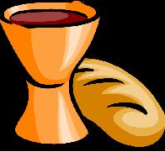 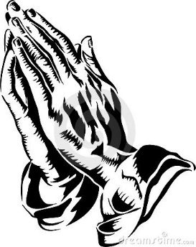 ?
Resurrection Eggs
“Why do you look for the living among the dead? He is not here; He has risen!”
Luke 24:5,6

